ASSINGMENT – 25

PROCEDURE WITH CURSOR

CODE:

create or replace procedure p_employee is

cursor c_employee is

select emp_id

from empl;

begin

for i in c_employee

loop

raise_sal(i.emp_id,10);

end loop;

end p_employee;

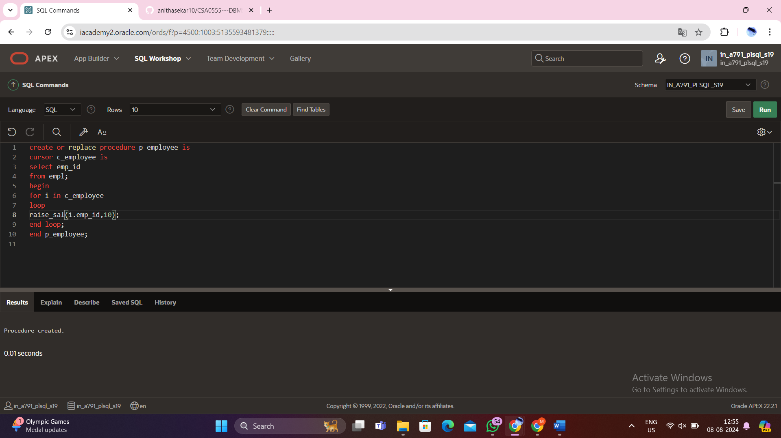

begin

p_employee;

end;

/

Output:

Select * from emp1;

